**Brand Name : Obsession outlet**

Kids chairs

# Intex Inflatable Cafe Chaise Lounge Chair and Ottoman, Orange

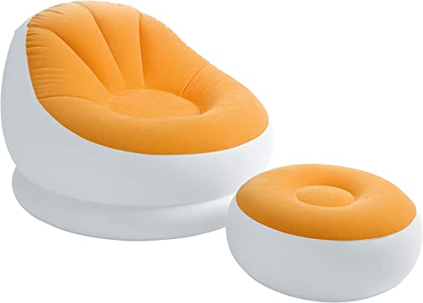**Description :**

### Product details

|  |  |
| --- | --- |
| **Color** | Orange,blue |
| **Brand** | Intex |
| **Item Weight** | 6.95 Pounds |
| **Model Number** | SYNCHKG051682 |
| **Product Dimensions** | 14.1"D x 11.1"W x 5.3"H |
| **Age Range (Description)** | Adult |

* INTEX Inflatable Colorful Cafe Chaise Lounge Chair w/ Ottoman - Blue | 68572E

**Rs:18,000**